Development Cycle
- Requirement Analysis
- Study requirement carefully
- Descript requirement by yourself into CCS http://ccs.sunplus.vn
Requirement analysis for documentation includes Audience Analysis, Need Analysis and Task Analysis. You try to understand the learning gap and come up with strategies required in achieving the project goal. You also decide the format and the delivery media for the document at this phase.
- Designing
- Create overview mockup and post to CCS
- Class designing for developing

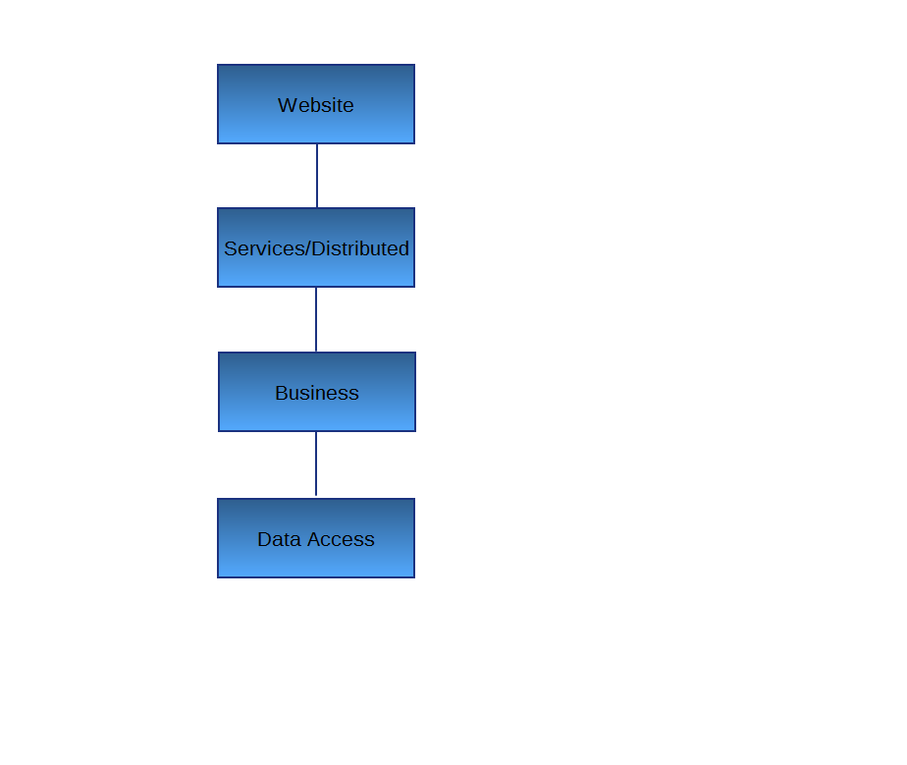

Design phase basically deals with collecting and organizing data. Design phase involves planning the instructional and media strategy and creating the course outline. High level design and low level design related to instructional and media strategy are created, verified, and validated.
- Developing
- Find the best solution for developing
Developing the document requires actual writing of the document, and integration of the various components (graphics, glossary, search items) of the document. This phase also involves document reviews and revisions and management of documentation issues. Now, the document is ready for testing.
- Testing
- Self-testing
- Pass to QA
Testing involves measuring the quality of the document. This involves review by quality analysts on parameters like correctness, completeness, adherence to standards, and usability.
- Publishing
After fixing the all the testing bugs the document is ready for publishing. After all the hard work this phase relates to actual delivery of the document to its target audience.
- Maintaining
Maintenance involves maintaining the deliverables. For example, it may involve content reuse analysis and elimination of redundant data from the document sets. It may also include template revision or inclusion of new product features.

